Course Level Project Report

**IOT-SENSORS AND DEVICES**

**(211ECE1400)**

|  |  |
| --- | --- |
| **Team Number** | GROUP-9 |
| **Project Title** | RAIN DETECTION ALARM CIRCIT USING ARDUINO |
| **Team Members**  **(Reg. No & Name)** | REG.NO:- NAMES |
| 99210041897 P.NARAHARI |
| 99210041896 P.BHANU PRAKASH |
| 99210042115 S.NEELA KRISHNA |
| 99210041961 T.MAHENDRA REDDY |
| 99210041945 M.MANOJ |
| 99210041928 K.BHANU PRAKASH |
|  |
| **Faculty In Charge** | DR. SHASHI KANT DARGAR |



BONAFIDECERTIFICATE

Bonafide record of work done by _______________________________________________ ___________________________________________________________________________

___________________________________________________________________________

___________________________________________________________________________ of ____________________________________________________________ Department during Odd semester in Academic Year 2022-23, as part of 211ECE1400 - IOT-Sensors and Devices Course level project.

**Faculty In charge Head of the Department**

Submitted for the evaluation of course level project of 211ECE1400 - IOT-Sensors and Devices course held on ______________

**Internal Examiner External Examiner**

**Table of Contents**

|  |  |  |
| --- | --- | --- |
| **S. No.** | **Name of the Content** | **Page No** |
|  | Abstract |  |
|  | Introduction |  |
|  | Motivation |  |
|  | Objective |  |
|  | Literature Survey |  |
|  | Proposed Approach |  |
|  | Experimentation and Results |  |
|  | Conclusions |  |
|  | Publication |  |
|  | References |  |

**1.ABSTRACT:**

* Rain alarm project is a very useful project which detects the rain and automatically triggers the alarm or buzzer.
* The sensor acts like a simple switch where the switch closes when it rains and is normally open when the rain stops.
* As water is basic need in everyone’s life. Saving the water and proper usage is very important.
* This project will trigger the alarm when it rains so we can make some actions for rain water harvesting and also to save the rain water for using it later for agriculture in fields.
* It is used in automobiles when the detector detects the rain it will automatically activates the windshield wipers of the vehicles.
* It can also be used in household for harvesting the rain water and increasing ground water storage instead of flowing it into drainage.
* So, the main purpose of this project is to prevent the material from rain, can be used in automobiles and in many other purposes.
* It is an easy and simple reliable circuit which can be constructed at a low cost.
* Rain Alarm is a device which is used to give the information is the rain is occurring as it gives sound when rain falls between the two aluminium rods.
* As the rain drop comes between the two rods the circuit gets completed and a sound is produced from the speaker indicating the falling of rain.
* It can be used in factories, open go downs where the goods need to be protected from rain.
* Rain water sensor is the main component in the circuit. For this rain sensor, no need to go and buy in the market or online.
* We can do it ourselves just by taking the piece of Bakelite or mica board and aluminium wire.
* Bakelite or mica board should be made completely flat and aluminium wire should be pasted on the flat board as shown in the figure below of rain water sensor.
* Care should be taken that there should be no spaces between the wire and board. When the rain water sensor is completed, it should get connected to the circuit and voltage should be passed through the wires.
* Water is a basic need in every one’s life. Saving water and proper usage of water is very important.

**2.INTRODUCTION:**

* The main idea of the project is to detect the rain fall using the rain sensor and it alerts the person to make some arrangements as in agriculture or in households to harvest the rain water and use it for later purposes.
* When the rain falls on the sensor it automatically triggers the buzzer and warns the person.
* As water is the main thing in human life we must try to save it and use for future purposes.
* Water is the most precious in our life for living so we must conserve water.
* Rain sensor can be made at a low cost and used in wide variety of area like in automobiles as it rains the wind shield wipers automatically switch on in the vehicle, uses in agriculture irrigation as the sensor detects rain it automatically stops the automatic irrigation system in the agriculture, used in household purposes to harvest the rain water and increase the underground water levels for using in future instead of flowing it into drainages.
* Management of water resources and proper usage have become increasingly important in recent years.
* Rain sensor senses rain and sounds an alert so that we can save water to use for other purposes later.
* For example, there are several methods for conserving water harvesting which means is the process of collecting and storing rainwater instead of letting it wash off.
* Rainwater is collected from a roof-like surface and directed to a tank, cistern, deep pit (well, shaft, or borehole), aquifer, or reservoir via percolation, where it seeps down and replenishes ground water.
* The level of ground water can be raised by conserving groundwater and limiting water use.

**2.1 MOTIVATION:**

* Water is a basic need in every one’s life. Saving water and proper usage of water is very important. Here is an easy project which will give the alarm when there is rain, so that we can make some actions for rain water harvesting and also save the rain water for using it later.
* With the help of saving this rain water through rain water harvesting, we can increase the levels of underground water by using underwater recharge technique.
* Rain water detector will detect the rain and make an alert; rain water detector is used in the irrigation field, home automation, communication, automobiles etc. Here is the simple and reliable circuit of rain water detector which can be constructed at low cost
  1. **OBJECTIVE:**
* The main objective of this project is to buzz an alarm when it detect rain water.
* Detect when it is raining.
* Shutoff power such as to the sprinkler system Conserve the natural rain water that can be harnessed for different purpose.
* Water conservation and good use are important. Here is a simple project that will sound an
* alarm when it rains, allowing us to take action to gather rainwater and store it for later use.
* We can increase the groundwater level with the aid of underwater recharge technologies by saving this rainwater and using it.
* When the rain detector senses rain, it sounds an alarm.
* The desired result was achieved in various aspects of using rainwater detectors in irrigation, home automation, electronics, vehicles, and other fields.
* Here is a low-cost rainwater detector circuit that is simple and effective.

3**.Literature Survey:**

* Rain alarm is a device which will really work as you wish what you want to do.
* It is a device which will generate the signal when the rain comes.
* The frequency will be more when the rain is heavy and the frequency is very less when the rain will be low.
* It all means that the frequency will depend upon the rain. The circuit will generate melodious tone whenever the rain starts.
* Rain water sensor a rain sensor is a rain switch device activated by a rain fall.
* There is two main applications for rain sensor. the first is water conservation device connected to an automatic irrigation system that cause the system to shutdown in the event of rain fall.
* The second is a device used to protect the interior of an automobile from rain and to support the automatic mode of wind screen wipers.
* An additional application in professional satellite communication as is to trigger a rain blower on the aperture of the antenna feed, to remove water droplets.
* IRRAGATION SENSOR Rain sensor in irrigation systems are available in both wireless and hard-wired versions, most employing hygroscopic disks that swell in the presence of rain and shrink back down again as they dry out.
* Wireless and wire versions both use similar mechanisms to temporarily suspend watering by the irrigation controller specifically they are connected to the irrigation

**4.Proposed Approach:**

* Rain Detection System using Arduino and Rain Sensor DAS UNO CNN Project Scenario: A simple Rain Detection System can be easily built by interfacing an Arduino with Rain Sensor. Rainfall detection can be used to automatically regulate the Irrigation process.
* Also, continuous rainfall data can help farmers use this smart system to automatically water the crop only when absolutely required.
* Similarly, in the automobiles sector windshield wipers can be made fully automatic by using the rain detection system Full Description: In this project, you will design a system that can detect to automatically close windows and adjust room temperature.
* The objective of this group is to build a basic rain sensor using Arduino with a buzzer and mechanical system that close the windows.
* The developed system should have the following parts: 10 . A final schematic proof of concept prototype with a code An alarm system with buzzer if there is rain in the room A mechanical system to close the windows if the buzzer if on after 5 seconds Implementation using Arduino or any similar microcontroller**.**

**5.Experimentation and Results:**

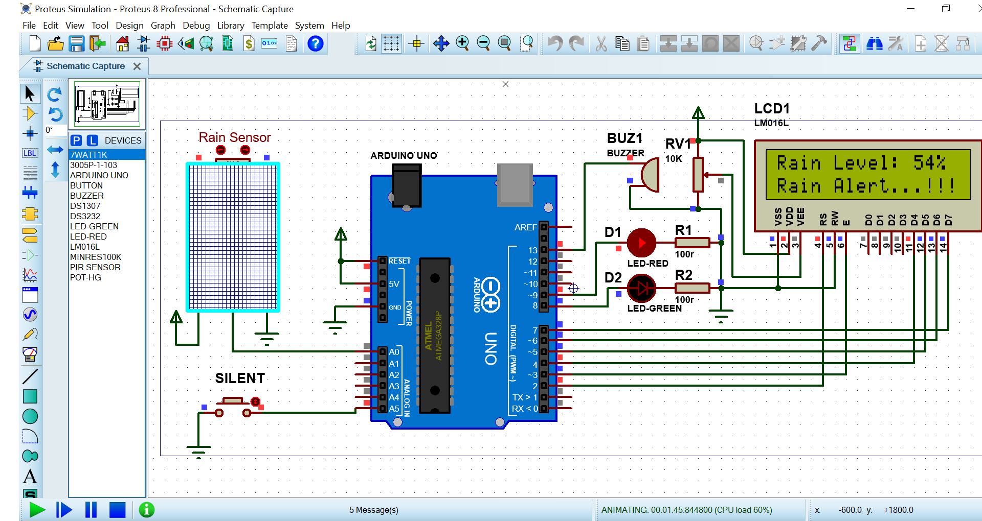

* The experiment is for switching an acoustic sounder as a rain alarm after a predetermine time.
* It may, however, be tinkered for a number of other applications. Needless to say, this is a simple experiment for Arduino beginners, but trying an experiment is even more pleasant when the result is something unique.
* The goal is now to use a pre-wired rain sensor module with an Arduino.
* Specification of the LM393 chip- based rain sensor module is given below:
* Working Voltage: 5V
* Indicators: Power indicator & Output indicator LEDs
* User Control: Onboard sensitivity adjustment potentiometer
* Output: Digital (DO) & Analog (AO).
* Here, the analog output (AO) of the rain sensor module is linked to one analog input (A0) of the Arduino, so that the microcontroller can read an analog voltage between 0 and 5 volts to process a number between 0 and 1023, where 0 representing 0 volt, and 1023 representing 5 volt.

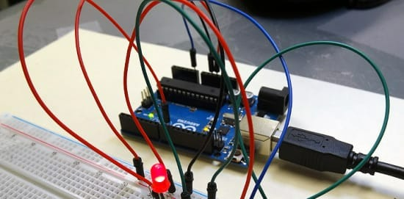

If the rain sensor plate of the rain sensor module is in dry state, analog output (AO) from the module is 5V. During rain, the sensor plate elements are bridged by the rain water and hence this analog output gradually changes from 5V to 0V, based on the moisture level between the sensor pads.

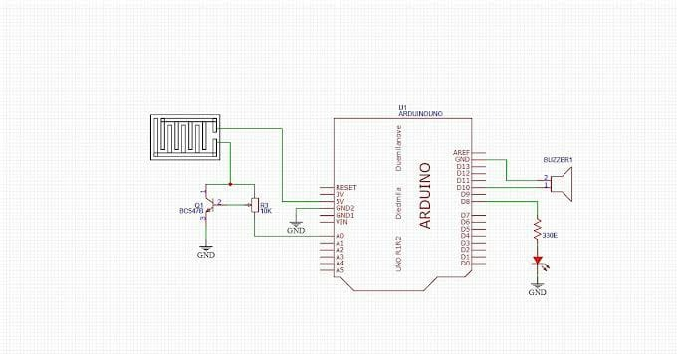

By this way, the sensor reports the absence and presence of the rain in an analog way, help us to determine whether the rain is light or strong by analyzing the outputted analog signal. The approximation is handled by a simple Arduino sketch. An additional function is delaying of the alert generation; Arduino raises an alert only when raining with a certain threshold is detected, within a pre-defined time interval. This extra feature helps in reducing false alarm counts to some extent. In the given sketch, rain threshold is 300, and the time delay is 30 sec.

**ARDUINO IDE PROGRAM:**

#include <LiquidCrystal.h>

LiquidCrystal lcd(2, 3, 4, 5, 6, 7);

#define sensor_pin A0 int adc_value;

int percent_value;

#define bt_silent A5int silent=0;

#define G_led 8

#define R_led 9

#define buzzer 13

void setup()

{

pinMode(sensor_pin, INPUT);

pinMode(bt_silent, INPUT_PULLUP);

pinMode(R_led,OUTPUT);

pinMode(G_led,OUTPUT);

pinMode(buzzer,OUTPUT);

lcd.begin(16, 2);

lcd.clear();

lcd.setCursor (0,0);

lcd.print(" Welcome To ");

lcd.setCursor (0,1);

lcd.print(" Rain Detector ");

delay(2000);

lcd.clear();

}

void loop()

{

adc_value= analogRead(sensor_pin);

percent_value = map(adc_value,0,1023,100,0);

if(digitalRead (bt_silent) == 0)

{

silent = 1;

delay(100);

}

lcd.setCursor(0, 0);

lcd.print("Rain Level: ");

lcd.print(percent_value);

lcd.print("% ");

lcd.setCursor(0, 1);

if(percent_value>30)

{

if(silent==0){digitalWrite(buzzer, HIGH);}

lcd.print("Rain Alert...!!!");

digitalWrite(G_led, LOW); // Turn LED off.

digitalWrite(R_led, HIGH); // Turn LED on.

delay(300);

}

else

{

silent=0;

lcd.print(".....Normal.....");

digitalWrite(G_led, HIGH); // Turn LED on.

digitalWrite(R_led, LOW); // Turn LED off.

}

digitalWrite(buzzer, LOW);

delay(100);

}

6**,CONCLUSION:**

* The rain water detector-alarm system will be useful in both domestic and industrial applications.
* It alerts the users of the presence of rain when itis just about to rain as even the minutest droplets of water triggers it ON thereby giving the user ample time to retrieve possessions, shut windows, and in some cases prepare to harvest rain water.
* The device when properly placed to receive the first set of droplets of rain water can save the user from damaging possessions that were being sundried/prevent rain from entering homes, offices and many industrial areas.
* The rain sensor can be made so sensitive that it can detect even the smallest drop of water and triggers the buzzer which is proved to be quiet reliable and consistent.

**7 PUBLICATIONS:**

* **In this project we publish news papers and pamphlet and social media while awareness of farmers and cotton industries .**
* **The main purpose of the project is to prevent the materials from rain.**
* **This is the new technology for farmers and it helps to farmers a lot.**
* **We are publish throughtout near by surroundings**.

**8 REFERNCE:**

* [1] [https://www.instructables.com](https://www.instructables.com/)
* [2] [https://makezine.com](https://makezine.com/)
* [3] [https://www.researchgate.net](https://www.researchgate.net/)
* [4] T. K. Gannavaram V, R. Bejgam, S. B. Keshipeddi, S. Sunkari and V. K. Aluvala, "Conversion of Sound Energy into Electrical Energy in Highly Populated Areas," 2021 6th International Conference on Communication and Electronics Systems (ICCES), 2021, pp. 32-36, doi: 10.1109/ICCES51350.2021.9489219.
* [5] T. K. Gannavaram V and R. Bejgam, "Brief Study and Review on the Next Revolutionary Autonomous Vehicle Technology," 2021 International Conference on Advance Computing and Innovative Technologies in Engineering (ICACITE), 2021, pp. 34-37, doi: 10.1109/ICACITE51222.2021.9404763.
* [6] T. K. Gannavaram V, R. Bejgam, S. B. Keshipeddi, A. Banda and G. Bollu, "Study of Automobile Safety Technology Development using Vehicular Safety Device (VSD)," 2021 6th International Conference on Inventive Computation Technologies (ICICT), 2021, pp. 240-244, doi: 10.1109/ICICT50816.2021.9358670.
* [7] T. K. Gannavaram V, U. Maheshwar Kandhikonda, R. Bejgam, S. B. Keshipeddi and S. Sunkari, "A Brief Review on Internet of Things (IoT)," 2021 International Conference on Computer Communication and Informatics (ICCCI), 2021, pp. 1-6, doi: 10.1109/ICCCI50826.2021.9457009.
* [8] T. K. Gannavaram V, U. M. Kandhikonda, R. Bejgam, S. B. Keshipeddi and S. Sunkari, "A Brief Review on Internet of Things (IoT)," 2021 International Conference on Computer Communication and Informatics (ICCCI), 2021, pp. 1-6, doi: 10.1109/ICCCI50826.2021.9451163.
* [9] Tummanapally, Shraddha Shree and Sunkari, Saideep, Smart Vehicle Tracking System using GPS and GSM Technologies (July 12, 2021). Available at SSRN: https://ssrn.com/abstract=3884903 or http://dx.doi.org/10.2139/ssrn.3884903